# EXPERIMENT-30

**NETWORK LAYER PROTOCOL HEADER ANALYSIS USING WIRE SHARK –HTTP**

**AIM**: To analyze capturing of Transport layer protocol header analysis using Wire shark- HTTP.

**SOFTWARE USED:**

Wire shark network analyzer

**PROCEDURE:**

1. Open wire shark.
2. Click on list the available capture interface.
3. Choose the LAN interface.
4. Click on start button.
5. Active packets will be displayed.
6. Capture the packets & select any IP address from the source.
7. Click on the expression and select IPV4 →IP addr source address in the field name.
8. Select the double equals (==) from the selection and enter the selected IP source address.
9. Click on apply button.
10. All the packets will be filtered using source address.

**OUTPUT**

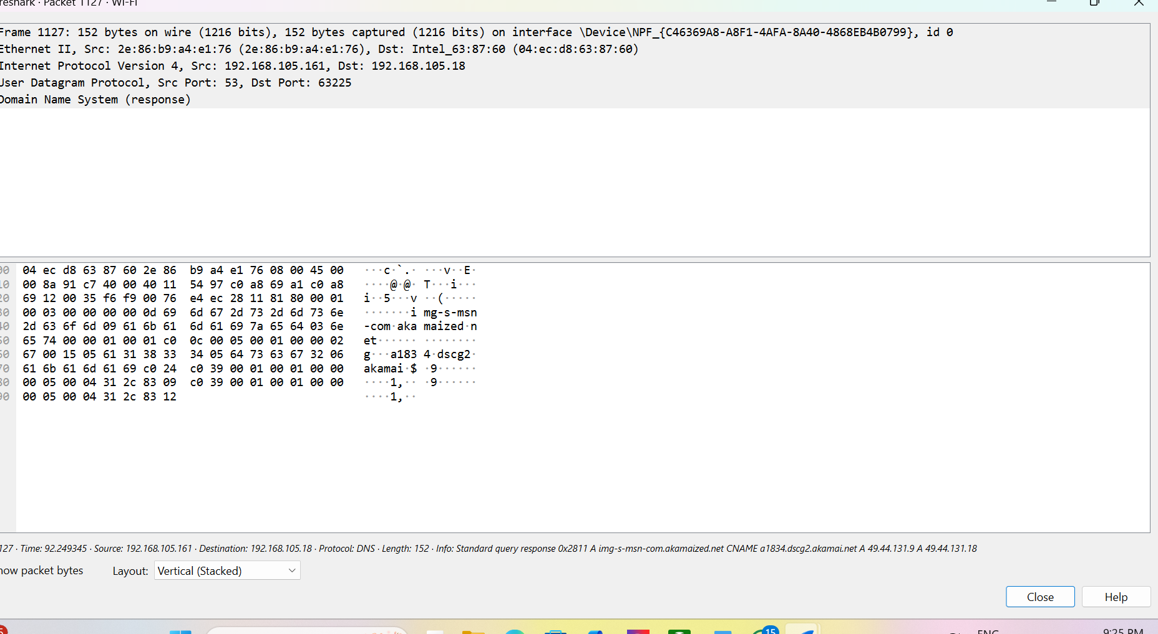

**Result:** Hence, the capturing of packets using wire shark network analyzer was analyzed for HTTP.